LPN SETTING& CALIBRATION MANUAL
A: Function setting:
Keypad diagram
7 | 8 | 9 | P1 | P2
4 | 5 | 6 | P3 | P4
1 | 2 | 3 | CE | PLU
0 | . | 00 |  | T

(1)numeric key 0 ~ 9 ：Used for setting unit price, numbers, calibration etc.
(2). decimal point key：
(3)00 To input 2 “0”
(4) P1, P2, P3 unit price hot key
(5).Tare key （ T ）：
(6)( >0< ): Zero key, backlight key:
Weight zero function(zero and zero range: ≤±100d(d1)）
(7) PLU unit price saving key
(8)CE clear key
(9) PRT :print key

1. Internal calibration
♦ Before calibration，make the 2 pins connected(short circuit), please put on the jumper on the ADJ position.
♦ After finishing the calibration, please remove jumper and park the jumper on Lock position
Firstly, please use switch to make the 2 pins of ADJ connected (short circuit) and turn on the scale, till the window shows all “8” and beep is on (twice), The weight window will show the Max Cap and division (eg:15.005 indicates the Max Cap:15kg,division:5g), unit price window show ”FUN”, Total price window show “SET”.(the ADJ is on the PCB main board)

Then please do as following,

0 | Zero hiding setting | Press ‘0’ key, weight window show ’o X’,  Unit window show ZERO, total price window show SET. then press ‘0’ key to select 0-9 hiding setting, press ‘tare’ key to confirm and press ‘zero’ key to return to normal weighing mode
1 | capacity setting | Press ‘1’ key, then weight window show current capacity, unit price window show ’CAP’, total price window show SET, press ‘1’ key to set the capacity .press ‘tare’ key to confirm and press ‘zero’ key to return to normal weighing mode
2 | division setting | Press ‘2’ key ,then the weight show d x, unit price window show d-set, total price window show set,then press ‘2’ key to select division in turn(1,2,5,10). Press ‘tare’ key to confirm and press ‘zero’ key to return to normal weighing mode.
3 | decimal setting | Press’3’ key, the weight window show dp x , unit price window show dpset, total price show set, press ’3’ key to select the (1 2 3). Press ‘tare’ key to confirm and press ‘zero’ key to return to normal weighing mode.
4 | Round up/down | Press ‘4’ key, then the weight window show ‘ON’ or ‘OFF,unit price show FEN total price show SET, press’4’ to select in turn. Press ‘tare’ key to confirm and press ’zero’ key to return to normal weighing mode.
5 | One range or two ranges setting(if 1-1 chosen, the scale works as one range; if 1-2 chosen, the scale works as two division, if choose S 1-2,the scale works as two range | Press ’5’ key, then the dow show ‘1-1’ or ‘1-2’ or'S 1-2, unit price window show dbset, total price show set, press’5’ to select in turn. Press ‘tare’ key to confirm and then press ‘zero’ key to return to normal weighing mode.
6 | check the internal value  (Zero internal value is about 140000,full capacity internal value is about 60000) | Press ‘6’ key, the weight window show pr xx, unit price window show FUN the total price window show current AD value. Press ‘tare’ key to confirm and press ‘zero’ key to return to normal weighing mode.
7 | selection ON/OFF of decimal | Press ’7’, then the weigh window show ‘ON’ or ‘OFF’, unit price show dot, total price show SET, press ‘7’ key in turn to select ‘ON’ or ‘OFF’, Press ‘tare’ key to confirm and press ‘zero’ key to return to normal weighing mode.

8 | RS232 output | Press 8’ key to select RS232 output from 0-15, the weight window show r x, the unit price window show r-232, total price window show blank  0~15  0：close the RS232 output  3：Data sending to Cash register Activa  4：Data sending to Cash register MP55  5: Data sending to Cash register DIBAL  6: Data sending to printer PPTII-A  7: 1200,N,8,1  8: 2400,N,8,1  9: 4800,N,8,1  10:9600,N,8,1  11:19200,N,8,1  12:38400,N,8,1  Same format for r7-r12.after stable,the scale send data continually e.g. weight:1.000kg,it send +1000g LF CR  r-13:9600,N,8,1 data send by ASCII communication  R-14:9600,N,8,1 data send by ASCII communication  r-15:9600,N,8,1 data send by ASCII communication
  Computer send | Scale send | note
  W or w or L or l |  | Please check note 1
   | <CR>03.0050<LF> | Weight is 3.005kg,please check note 4
  Computer send | Scale send | note
  W or w |  | Please check note 2
   | <CR>03.0050<LF> | Weight is 3.005kg,please check note 4
  Computer send | Scale send | note
  L or l |  | Please check note 3
   | <CR>03.0050<LF> | Weight is 3.005kg,please check note 4

9 | P4/print function | Press “9” key, the weight window show “15.005”, unit window show “FUN”, total price show “5EE”. press”9” key to select on or off. Choose on to select P4 price hot key function,Choose off to select print function.

Note1:The computer send one of W w L l to scale,after the scale is stable,the scale will send the net weight to computer.

Note2:The computer send one of W w to scale,after the scale is stable,the scale will send the net weight to computer.

Note3:The computer send one of L l to scale,after the scale is stable,the scale will send the net weight to computer.

Note4:
e.g.1
No tare weight,net weight is 0,after the scale receive the command,it will reture the following data to computer：
character | CR | 0 | 0 | . | 0 | 0 | 0 | 0 | LF
hex | 0D | 30 | 30 | 2E | 30 | 30 | 30 | 30 | 0A

e.g.2
No tare weight，net weight is 3.005kg，after the scale receive the command,it will reture the following data to computer

character | CR | 0 | 3 | . | 0 | 0 | 5 | 0 | LF
hex | 0D | 30 | 33 | 2E | 30 | 30 | 35 | 30 | 0A

e.g.3
Tare weight is 1kg，net weight 3.005kg，after the scale receive the command,it will reture the following data to computer

character | CR | 0 | 3 | . | 0 | 0 | 5 | 0 | LF
hex | 0D | 30 | 33 | 2E | 30 | 30 | 35 | 30 | 0A

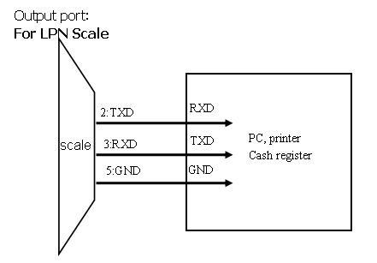

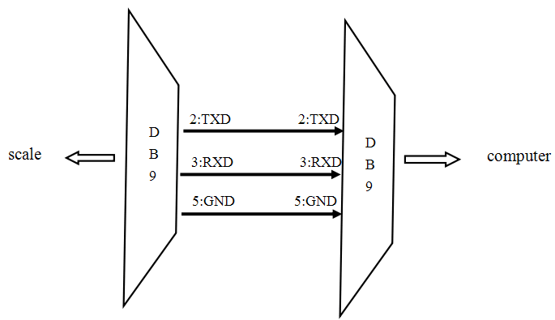

B: weighing calibration:

Firstly, please use pincers to make the 2 pins of ADJ connected (short circuit) and turn on the scale, till the window shows all “8” and beep is on (twice), then remove the jumper to LOCK position, The weight window will show the Max Capacity and division (eg: 15.005 indicates the Max Cap: 15kg, division: 5g), unit price window show ‘FUN’, Total window show “SET”.

Press ‘>0<’ key to go into calibration mode, the weight window will show the calibrate weight, unit price window show ‘CAL’. Press ‘T’ to confirm directly(or press number keys to select the calibrated weight, then press ‘T’ to confirm), the unit price window show ‘LOAD’, then load the corresponding weight mass, the unit price window show ‘LOAD’, Total price window show the internal value, press ‘tare’ to confirm, till the unit price window show ‘PASS’, unload the weight mass.

